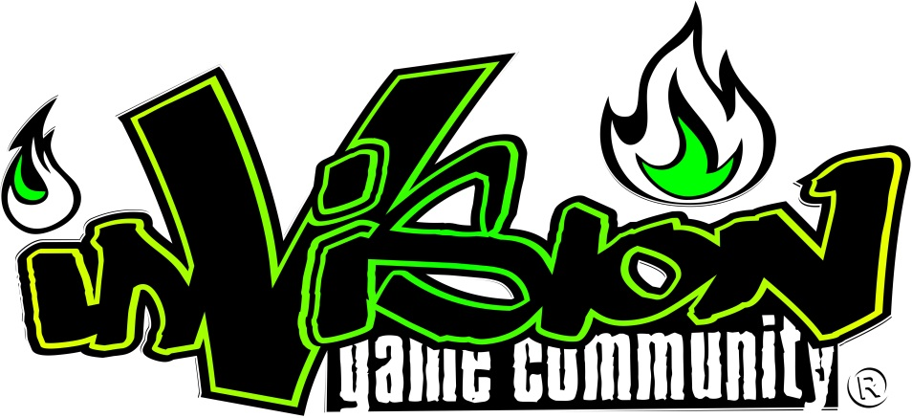
Invision Gaming Community expects all of its employees to comply with the code of conduct set out by management, at all times. If these rules are disregarded in any way, or an employee behaves in a way deemed as inappropriate, then management at Invision Gaming Community reserves the right to discipline employees as they see fit.
Disciplinary action may consist of any of the following; a formal oral warning, written warning, a final written warning, and dismissal, or in the case of gross misconduct, summary dismissal.
Rules
- Employees should comply with the terms of their employment that they sign when joining Invision Gaming Community.
- Employees should follow all instructions given for carrying out the function of their roles of employment, and perform their roles to a satisfactorily standard.
- Employees should satisfactorily perform any reasonable request relating to their role if issued by an authorised manager.
- Threatening, aggressive or violent behaviour or language is not permitted and may lead to dismissal – this applies both during working hours and outside of the work environment.
- Discriminatory behaviour or language is not permitted and anyone committing these offences will be punished by authorised management as seen fit.
- Bullying of individuals or groups, in any form, is not tolerated and again, anyone committing these offences will be punished by authorised management as seen fit.
- Any disclosure of confidential information concerning the work of Invision Gaming Community or its employees is not permitted and if broken, will be punished accordingly(this does not affect the employee's rights under the Public Interest Disclosure Act 1998).
- Employees must not behave in a way that brings or may bring Invision Gaming Community into disrepute.
- Employees will treat viewers of Invision Gaming Community and commenters on the companies pages with respect at all times.
- Employees must not advocate, promote or support the piracy of video games in the public eye, on Invision pages or any Invision associated pages.
- Employees will take responsibility for anything they post in public spaces such as, but not limited to, Twitter and Facebook. Employees will not slander, mock, or be unreasonable about any gaming companies or workers, including but not limited to publishers and developers.
The following are examples of the kind of behaviour which can constitute gross misconduct and which could lead to summary dismissal:
- Physical violence towards anybody: this applies to your role as an employee but also outside of the work environment
- Serious misuse of the trust that exists between employees and anyone for whom Invision Gaming Community is responsible
- Gross insubordination
- Slandering companies we are associated with in the view of the public eye.
- Serious infringement of the rules of Invision Gaming Community
- Employees must not approach developers or publishers with requests for games under their own name or Invision's name for their own concept or personal gain without discussing it with Invision prior.

